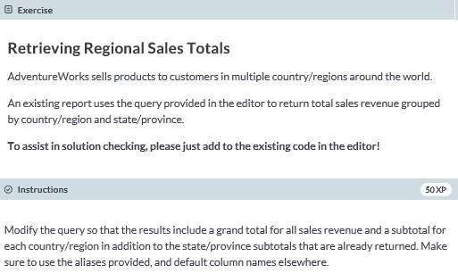

**SELECT a.CountryRegion, a.StateProvince, SUM(soh.TotalDue) AS Revenue**

**FROM SalesLT.Address AS a**

**JOIN SalesLT.CustomerAddress AS ca**

**ON a.AddressID = ca.AddressID**

**JOIN SalesLT.Customer AS c**

**ON ca.CustomerID = c.CustomerID**

**JOIN SalesLT.SalesOrderHeader as soh**

**ON c.CustomerID = soh.CustomerID**

**-- Modify GROUP BY to use ROLLUP**

**GROUP BY ROLLUP(a.CountryRegion, a.StateProvince)**

**ORDER BY a.CountryRegion, a.StateProvince;**

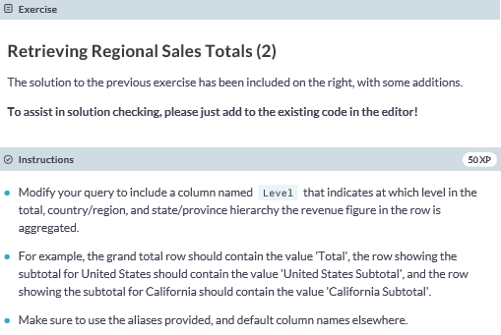

**SELECT a.CountryRegion, a.StateProvince,**

**IIF(GROUPING_ID(a.CountryRegion) = 1 AND GROUPING_ID(a.StateProvince) = 1, 'Total', IIF(GROUPING_ID(a.StateProvince) = 1, a.CountryRegion + ' Subtotal', a.StateProvince + ' Subtotal')) AS Level,**

**SUM(soh.TotalDue) AS Revenue**

**FROM SalesLT.Address AS a**

**JOIN SalesLT.CustomerAddress AS ca**

**ON a.AddressID = ca.AddressID**

**JOIN SalesLT.Customer AS c**

**ON ca.CustomerID = c.CustomerID**

**JOIN SalesLT.SalesOrderHeader as soh**

**ON c.CustomerID = soh.CustomerID**

**GROUP BY ROLLUP(a.CountryRegion, a.StateProvince)**

**ORDER BY a.CountryRegion, a.StateProvince;**

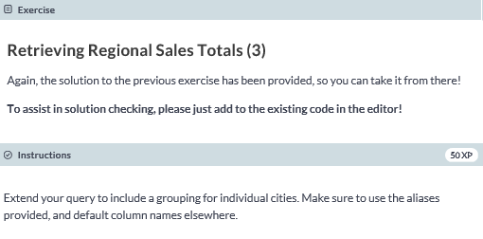

**SELECT a.CountryRegion, a.StateProvince, a.City,**

**CHOOSE (1 + GROUPING_ID(a.CountryRegion) + GROUPING_ID(a.StateProvince) + GROUPING_ID(a.City),**

**a.City + ' Subtotal', a.StateProvince + ' Subtotal',**

**a.CountryRegion + ' Subtotal', 'Total') AS Level,**

**SUM(soh.TotalDue) AS Revenue**

**FROM SalesLT.Address AS a**

**JOIN SalesLT.CustomerAddress AS ca**

**ON a.AddressID = ca.AddressID**

**JOIN SalesLT.Customer AS c**

**ON ca.CustomerID = c.CustomerID**

**JOIN SalesLT.SalesOrderHeader as soh**

**ON c.CustomerID = soh.CustomerID**

**GROUP BY ROLLUP(a.CountryRegion, a.StateProvince, a.City)**

**ORDER BY a.CountryRegion, a.StateProvince, a.City;**

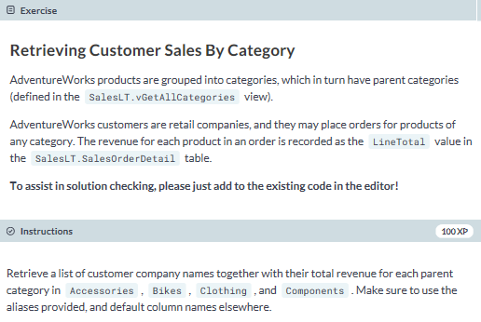

**SELECT * FROM**

**(SELECT cat.ParentProductCategoryName, cust.CompanyName, sod.LineTotal**

**FROM SalesLT.SalesOrderDetail AS sod**

**JOIN SalesLT.SalesOrderHeader AS soh ON sod.SalesOrderID = soh.SalesOrderID**

**JOIN SalesLT.Customer AS cust ON soh.CustomerID = cust.CustomerID**

**JOIN SalesLT.Product AS prod ON sod.ProductID = prod.ProductID**

**JOIN SalesLT.vGetAllCategories AS cat ON prod.ProductcategoryID = cat.ProductCategoryID) AS catsales**

**PIVOT (SUM(LineTotal) FOR ParentProductCategoryName**

**IN ([Accessories], [Bikes], [Clothing], [Components])) AS pivotedsales**

**ORDER BY CompanyName;**